Technical Design Document
Algorithms:
- Pathfinding for each enemy, such as a direct beeline towards the player, or finding a spot on the map to reach instead.
- Algorithm required for the director to spawn enemies, increasing the price of certain enemies to ensure they aren’t too common compared to others
- Random Algorithm for picking upgrades for the player, being able to select from a list of applicable upgrades that the player can branch off from and be updated with new upgrades.
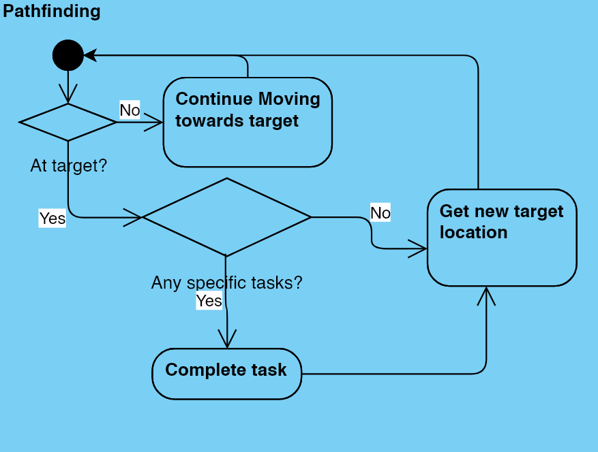
Pathfinding:
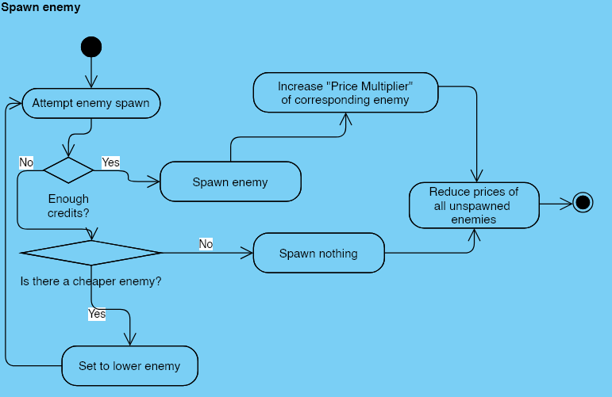
Director Algorithm:
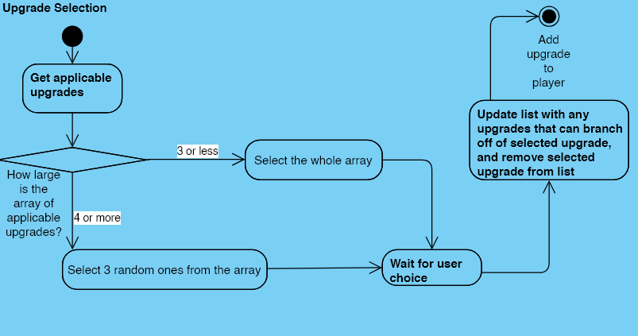
Upgrade Selection:
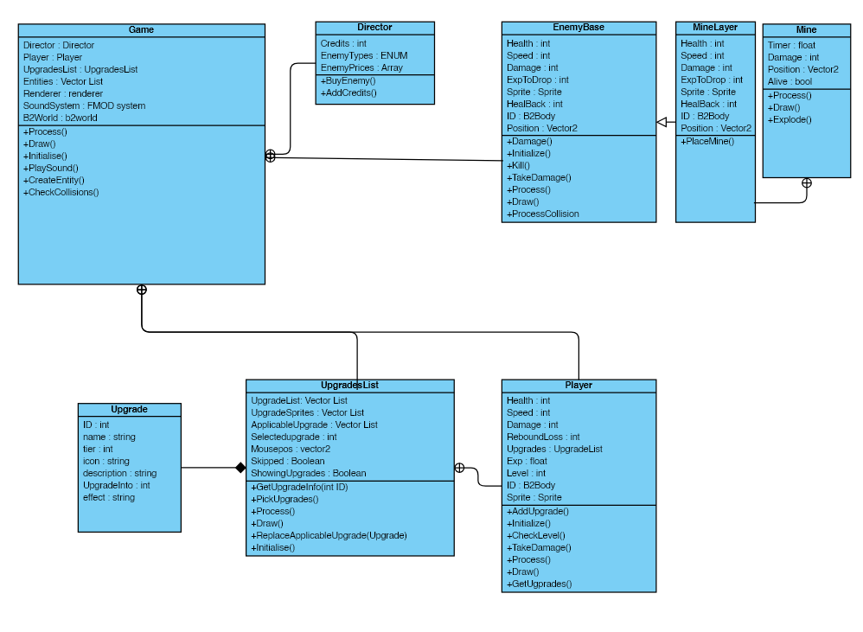
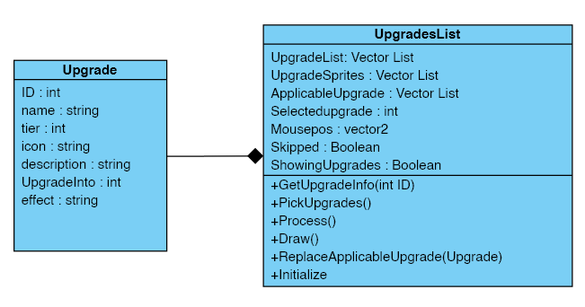
UML Class Diagram:

Debug Features:
- Player info
- Health
- Damage
- Momentum
- Positions of various items (mouse, player)
- Velocity
- Cheats
- Enemy info
- Type
- Damage
- Health
- Scene selector (splash screen and game)
- Director info
- Enemy costs
- Credits
Coding Standards:
- Pointers start with m_p for ease of distincting
- Names are consistent with their function
- Comments are used to keep functions and variables understandable
- All enemy related files are stored in enemies folder in assets, upgrades in upgrade folder.
Relevant file formats:
- OTF, TTF for fonts
- Png for sprites
- Wav for sound
- .cpp and .h files for code
- Lib,dll for libraries and other external resources
Acceptance Test:
- Can the game open?
- Can the game restart?
- Can the player kill enemies?
- Does levelling up work?
- Do upgrades actually apply to the player?
- Does the director spawn enemies?
- Can the player leave the screen space?
- Will the player be able to move quickly?
- Does the game render everything in proper order?
- Are all objects affected by deltatime and move consistently?

